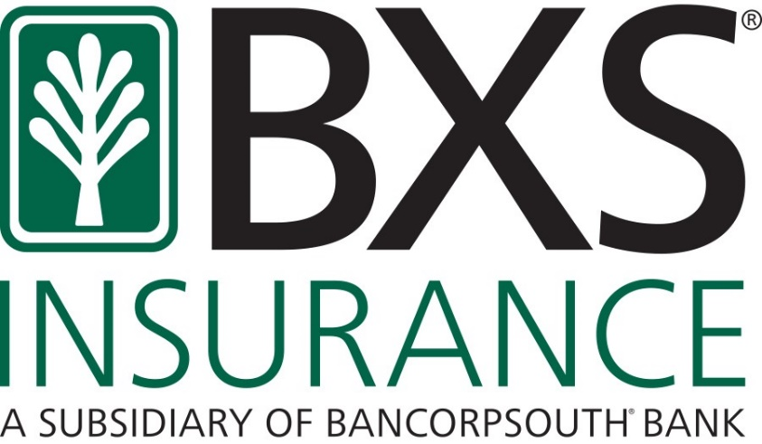
Employers should be aware of how the COVID-19 pandemic may impact 4 key areas of compliance with ACA:
- ALE Status Considerations
Determining ALE status may require revised projections for the upcoming calendar year. Classifying employees incorrectly can lead to overcounting or undercounting of employees. Calculations require monthly totals for both full-time and full-time equivalent (i.e., part-time employees).
- Employee Status Considerations
Remember, full-time status is based on “hours of service.” This includes hours actually worked and hours for which the employee is entitled to payment.
- Paid Leave
If an employee is on paid leave, the hours should be counted toward full-time status. This is true whether they have contracted the virus or are on leave as a preventive measure.
- Unpaid Leave
If an employee is on unpaid (non-FMLA) leave, the absence of hours would factor into the monthly calculation under both the monthly or look-back measurement methods.
- FMLA Leave
Employees on FMLA leave (whether COVID-19 related or not) should have their period of leave disregarded or credited with the average hours of service during that leave period.
- Measurement Period Considerations
Many employers who had previously used the Monthly Measurement Method may want to consider their approach if their workforce and their hours of service start to fluctuate with the pandemic. For those who already use the Look-Back Measurement Method, accurately tracking hours just became that much more important for accurate compliance.
- Affordability Considerations
Employers who currently use the W-2 safe harbor as their affordability method may consider changing their affordability safe harbor by end of year if the below are applicable to their company:
- Unpaid leave
- Reduced commissions and contingent income for sales
BXS Insurance is closely monitoring changes and the impact on our clients. We will send out updates as they become available.
Please take action with your clients to make sure they understand these considerations.
Amy
Amy R. Underwood
Director of Sales, Employee Benefits
Vice President & Director of Resources Innovation
BXS Insurance | 4041 Essen Lane Suite 400 | Baton Rouge, La 70816
(O) 225-215-9436 | (M) 225-284-5178 | amy.underwood@bxsi.com | bxsi.com

